Eggplants .

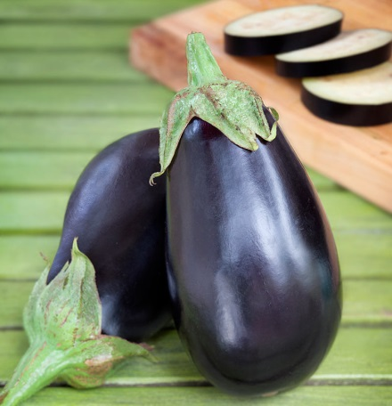
Black Beauty
Tender, tasty purplish-black fruits are great in a variety of dishes. Excellent breaded or fried. Plants produce 4 to 6 large fruit, or more if kept harvested and well watered. Fruit makes a good “boat” for stuffing. For best quality, harvest before its glossy, dark skin begins fading to dull purple. To determine ripeness, just remember that skin color and tone (glossy versus dull) is more important than size of the fruit.

Early Long Purple

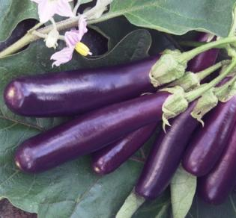
Milder, more delicate flavor than Black Beauty. Few seeds and thin skin also make it easy to cook. Flavor is sweet and mild.

Eggplants .

Black Beauty
Tender, tasty purplish-black fruits are great in a variety of dishes. Excellent breaded or fried. Plants produce 4 to 6 large fruit, or more if kept harvested and well watered. Fruit makes a good “boat” for stuffing. For best quality, harvest before its glossy, dark skin begins fading to dull purple. To determine ripeness, just remember that skin color and tone (glossy versus dull) is more important than size of the fruit.

Early Long Purple

Milder, more delicate flavor than Black Beauty. Few seeds and thin skin also make it easy to cook. Flavor is sweet and mild.

